

Ethnicity Classification with a Fully Connected Neural Network

Lab 04

|  |  |
| --- | --- |
| NAME | RAJA HAIDER ALI |
| CMS ID | 346900 |
| GROUP | 2 |

# Introduction

This lab aims to build a fully connected neural network for the classification of ethnicity based on facial image data. The dataset used contains pixel values of facial images, along with corresponding ethnicity labels. The goal is to create a robust model that can accurately classify ethnicity from facial features.

# Data Generation and Preprocessing

The dataset initially contained many samples, and to make it manageable, we randomly sampled 7,000 records from it using a fixed random seed. The dataset was then preprocessed to prepare it for model training.

Data Splitting: The dataset was split into training (70%), validation (15%), and testing (15%) subsets. This was achieved using the train_test_split function from the scikit-learn library.

Data Normalization: The pixel values in the images were normalized by scaling them to the range [0, 1]. This step helps improve model convergence and training stability.

# Model Architecture

The neural network architecture used for this task is a fully connected (dense) neural network. The model consists of four fully connected layers with ReLU activation functions, followed by a softmax layer for multi-class classification.

Input Layer: The input size was determined by the dimensions of the image data.

Hidden Layers: There are three hidden layers with 512, 256, and 128 units, respectively. These layers apply the ReLU activation function to introduce non-linearity.

Output Layer: The output layer has as many units as there are unique ethnicity classes in the dataset. The softmax activation function is applied to obtain class probabilities.

L2 Regularization: L2 regularisation is used to prevent the model from overfitting with the value of lambda = 0.001.

# Training Process

The model was trained using the training dataset, and its performance was evaluated on the validation set. The following training process was followed:

Loss Function and Optimizer: Cross-entropy loss was used as the loss function, and the Adam optimizer was chosen for optimization.

Training Loop: The training loop ran for 150 epochs. In each epoch, the model was set to training mode, and batches of training data were processed. The optimizer computed gradients, and the model weights were updated to minimize the loss.

Validation: After each epoch, the model's performance was evaluated on the validation set. This allowed us to monitor the model's generalization and prevent overfitting.

# Evaluation Results

The model's performance was evaluated on the test set using accuracy and the confusion matrix:

Test Accuracy: The final model achieved a test accuracy of approximately 60.57%.

Confusion Matrix: The confusion matrix visually represents the model's performance in classifying different ethnicities. It provides insights into the number of true positive, true negative, false positive, and false negative predictions for each class.

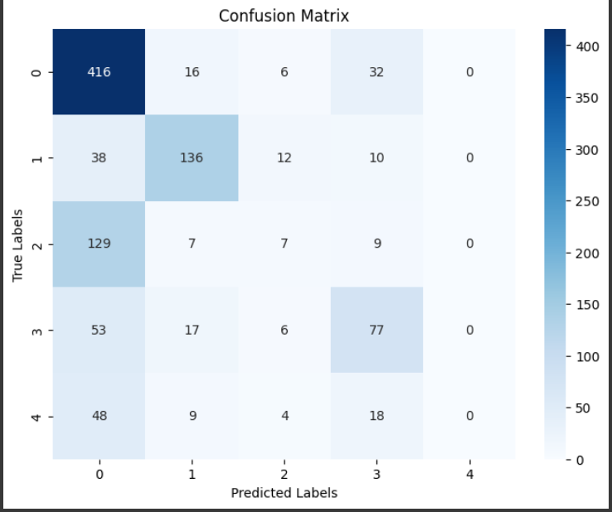

# Conclusion

In this lab, we successfully built and trained a fully connected neural network for ethnicity classification using facial image data. The model demonstrated reasonable accuracy in predicting ethnicity based on facial features. Further improvements could be made by experimenting with different model architectures, hyperparameters, and data augmentation techniques to enhance the model's performance.